Predicting Near-Earth Object Hazards Using Data Science



Abstract
This project aims to analyze a dataset of Near-Earth Objects (NEOs) obtained from NASA to understand their characteristics and assess their potential hazards. By
leveraging advanced data preprocessing, feature selection methods, and visualization techniques, this study identifies the most relevant attributes influencing hazard status. A combination of filter, wrapper, and embedded methods was employed, alongside optimization-based feature selection using Particle Swarm Optimization (PSO), to enhance the model's predictive accuracy.

Introduction
Near-Earth Objects are celestial bodies that orbit close to Earth, posing varying degrees of risk. This project uses a dataset with 4,687 entries and 40 attributes, including dimensions, velocities, and orbital parameters. The study's objective is to analyze and classify these objects into hazardous and non-hazardous categories, using advanced feature selection and machine learning techniques.

Objectives
- Perform exploratory data analysis and preprocessing.
- Use advanced feature selection methods to identify the most impactful variables.
- Evaluate the performance of selected features on classification models.
- Implement and compare filter, wrapper, and embedded methods, as well as PSO for feature selection.
- Visualize the findings for intuitive interpretation.

Methodology

Dataset Overview:
  - The dataset sourced from NASA, includes attributes such as absolute magnitude, estimated diameters, close approach data, and orbital parameters
  - The target variable (Hazardous) was transformed into a binary column labeled (Dangerous) for classification purposes.

Data Preprocessing:
  - Checked for missing values (isnull().sum()) and confirmed data consistency.
  - Split numerical (asteroid_num) and categorical (asteroid_cat) features for specialized analysis.
  - Visualized numerical data using boxplots to inspect outliers.

Feature Selection:
- Filter Method:
  - Point Biserial Correlation was applied to assess relationships between the binary target and continuous features. Features with significant correlations were shortlisted.

Wrapper Method:
  - Sequential Feature Selector (SFS) with Logistic Regression performed backward elimination to identify the most relevant features, improving model accuracy.

Embedded Method:
  - Lasso Regression used regularization to eliminate irrelevant features and select impactful ones.

Optimization-Based Feature Selection:
  - Particle Swarm Optimization (PSO) was applied to optimize feature subsets, minimizing redundancy while maximizing model accuracy.

Tools and Libraries:
- Python, with libraries including:
  - Pandas: Data manipulation and preprocessing.
  - Scikit-learn: Feature selection, modeling, and evaluation.
  - Pyswarms: PSO-based optimization for feature selection.
  - Seaborn and Matplotlib: Visualization.

Model Evaluation:
  - Metrics such as accuracy, R-squared, and mean squared error were computed to validate model performance.

Results and Findings

Feature Selection:
  - Point Biserial Correlation identified features like relative velocity and minimum orbit intersection distance as significantly related to the target variable.
  - SFS reduced the feature set to 8 key attributes, improving model performance.
  - PSO further optimized feature selection, achieving an accuracy improvement of 95% .
  - Lasso Regression highlighted relevant features while controlling for multicollinearity.
  - Some features selected were the same for many techniques i.e Minimum Orbit Intersection , Orbit Uncertainty , Absolute Magnitude , Estimated Diameter in miles.

Model Performance:
  - Logistic Regression achieved a baseline accuracy of 90.33%
  - Feature selection methods, particularly PSO, significantly enhanced the model's predictive accuracy.

Comparison:
  - Backward elimination : 95%
  - PSO : 96%
  - Lasso : 94%
  - All features : 95%
  - Physically important features : 88%


The PSO method proved to be the most effective model.

Exploratory Data Analysis

Box plot for outlier detection:

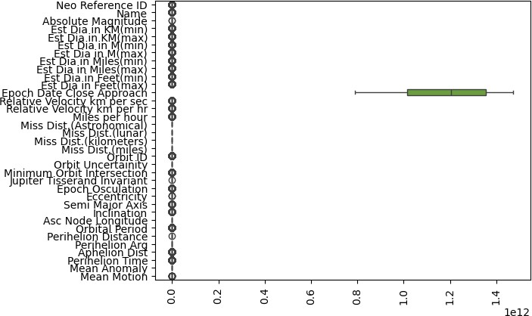

Heatmap for Correlation analysis and Checking multicollinearity:

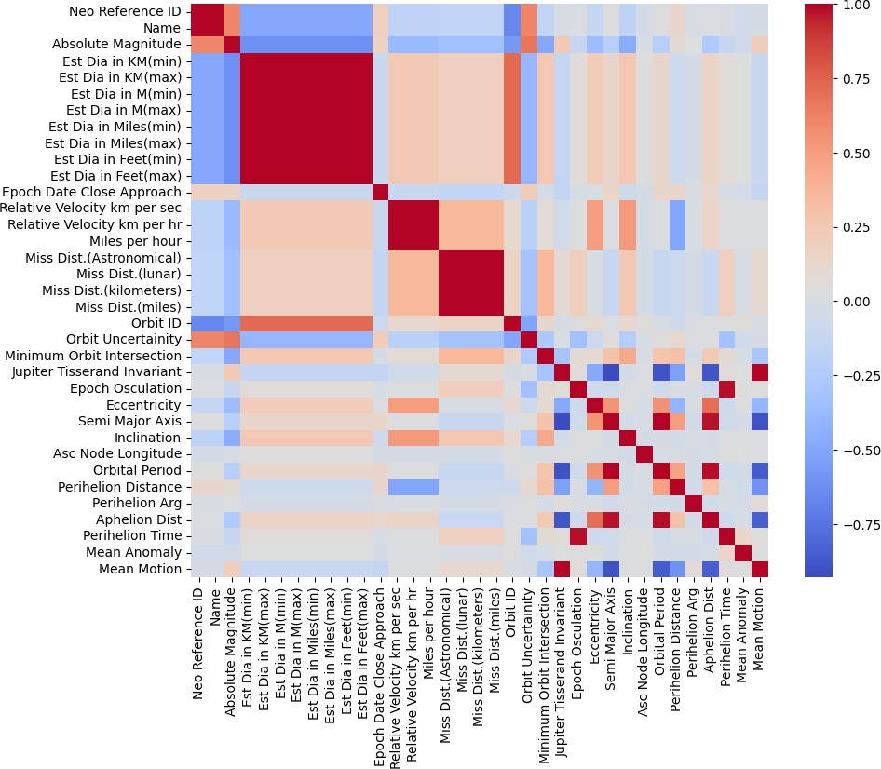

Histograms of important feature:

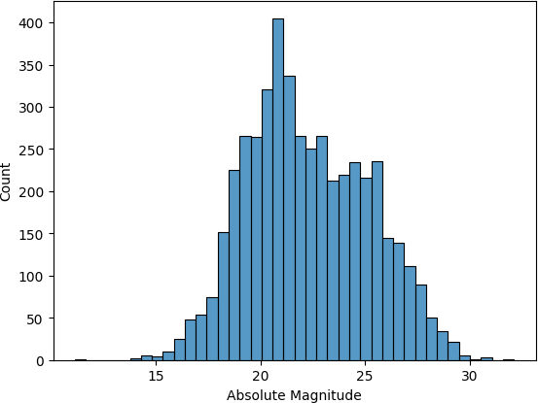
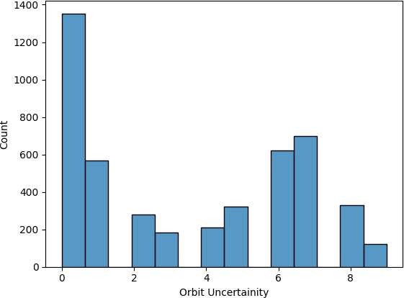

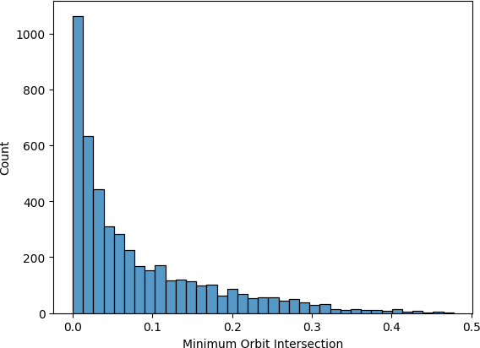

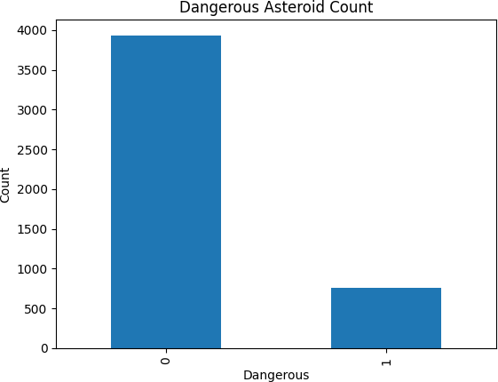
Sizes and Distribiutions of different types of asteroids :

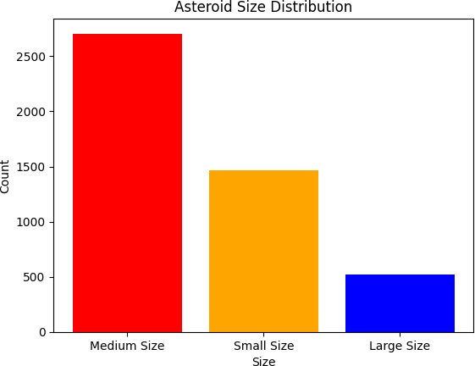

–

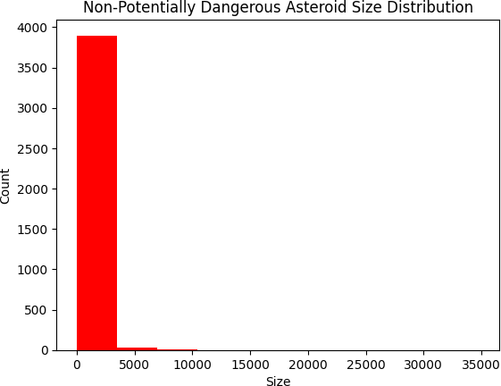

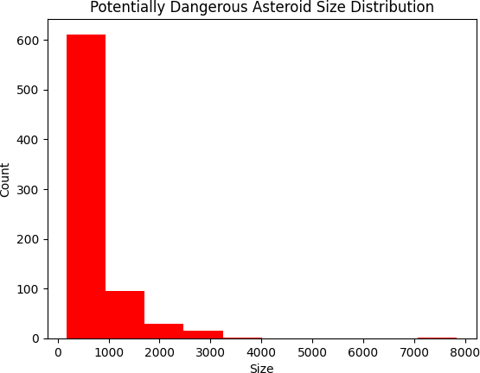

Conclusions
This study successfully applied advanced feature selection techniques to analyze NASA's NEO dataset. The integration of filter, wrapper, embedded, and optimization-based methods ensured robust feature selection, improving model performance. These findings contribute to better understanding and monitoring of potentially hazardous objects.

Impact:
  - Contributes to planetary defense by enhancing our ability to predict hazardous NEOs.
  - Offers a scalable methodology for future research in astronomical data analysis.

